**Apache Superset Installation**

1. sudo apt update

2. sudo apt install python3-pip

3. pip3 --version

4. pip3 install virtualenv

5. sudo apt-get install python3-venv

6. python3 -m venv supersetdata

7. . supersetdata/bin/activate

8. pip install --upgrade setuptools pip

9. pip install apache-superset

10. superset db upgrade

11. export FLASK_APP=superset

12. superset fab create-admin

( Username [admin]: admin

User first name [admin]: admin

User last name [user]: admin

Email [admin@fab.org]: xyz@gmail.com

Password:

Repeat for confirmation: )

13. superset load_examples

14. superset init

15. superset run -p 8088 --with-threads --reload --debugger

Enter the URL in your Browser:- [**http://127.0.0.1:8088/**](http://127.0.0.1:8088/)

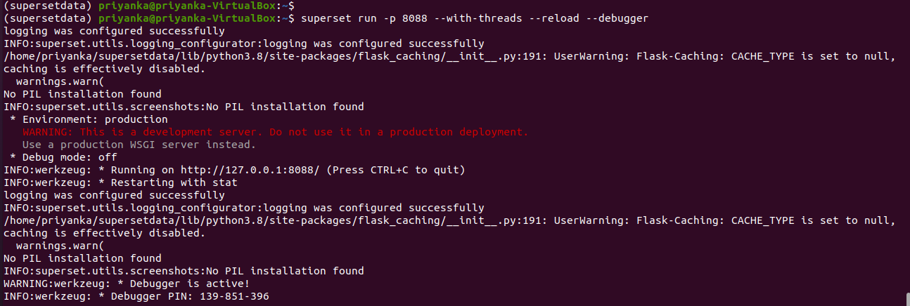

# Dashboard

